

**UNIVERSITY OF GREENWICH**

COMP1640

–

|  |
| --- |
| Enterprise Web |

Coursework

Software Development

|  |  |
| --- | --- |
| Student | **Mai Hoang Minh Thai** |
| ID number | **001353467** |
| Supervisor | **Doan Dinh Ho** |
| Student submission date | **November 24th, 2023** |
| Word count |  |

**Table of content**

**I.** **Introduction** 4

**II.** **Evaluation** 5

**1.** **The Product** 5

**1.1.** **Nielsen’s Heuristics for User Interface Design** 8

**1.2.** **What else could be done** 10

**2.** **The Process** 10

**3.** **The team** 11

**3.1.** **Team Evaluation** 11

**3.2.** **Team Justification** 12

**4.** **Self-Evaluation** 13

**III.** **Conclusion** 14

**References** 15

**Table of Figure**

Figure 1. Home Page 5

Figure 2. Login Page 5

Figure 3. White and Teal colours implemented on the website 7

Figure 4. Website showing easy navigation 8

Figure 5. Responsive design on the homepage 9

Figure 6. Bcrypt hash security feature in the database 9

Figure 7. Visibility of system Status 10

Figure 8. User control and freedom 10

Figure 9. Aesthetic and minimalist design 10

Figure 10. Help users recognize, diagnose, and recover from errors 11

Figure 11 & 12. Team Evaluation 13

1. **Introduction**

The coursework aimed to work to develop a role-based system by working in a scrum team. A large university will use the method to collect student contributions annually. The intention was to enable different system users to carry out certain tasks within the system. The Annual University Magazine is the name of the system. The scrum team created and refined it and the scrum team included a product owner, database engineer, web designer, programmer, tester, and scrum master make up the team. Because the scrum team documented weekly meeting minutes, user stories, and sprint backlogs, they were able to collaborate effectively and produce a high-quality solution on schedule. The report will discuss the author's involvement in the system's design and development phase. Along with relevant pictures that succinctly outline the system's main features, the report will also include a brief description of the deployed system. The finished product will be carefully assessed, as well as any potential future additions to the system and whether or not the criteria for the product were fulfilled. The process and design methodologies employed, the efficacy of the scrum methodology, and the level of communication within the scrum team will all be thoroughly assessed by the author. An Excel spreadsheet will be used to help with the assessment process, which will involve rating each team member. The author's participation to the group project, presentation, and final output will then be evaluated.

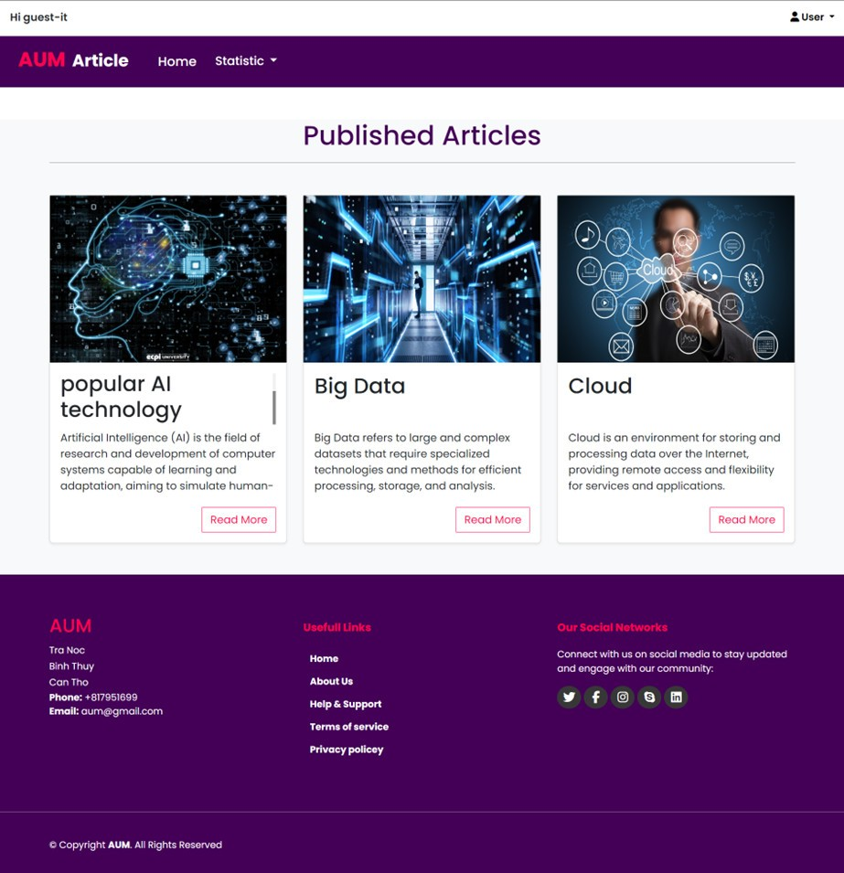

Figure 1. Home Page

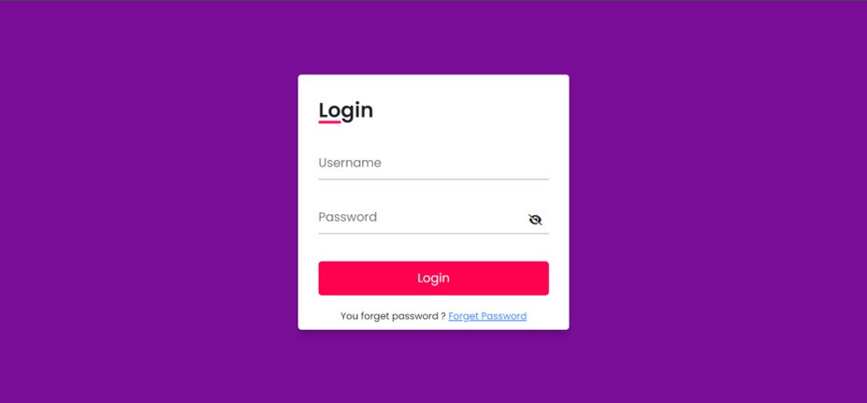

Figure 2. Login Page

1. **Evaluation**
2. **The Product**

The product that was developed was made to satisfy the list of requirements that the client gave. The website, which was necessary for the collection of student contributions, has all of these conditions satisfied and is visible. Because ASP.Net Core is comparatively quick and user-friendly, it was used in the creation of the product. The system's client wanted certain functional capabilities to be deployed first, and those functions included requiring students to upload high-quality photographs and submit articles. The scrum team used an incremental and iterative method to meet the requirements of the system. This is an essential part of adopting Scrum as a development framework when creating a system for a customer. The group began by choosing product backlogs that could be completed in a single sprint, such as students editing their own submissions and a marketing coordinator providing feedback based on student contributions. This allowed room for documenting and testing these functionalities before working on backlogs that had to be split into multiple sprints.

* Benefits of the developed system
* Usability: The product has a user-friendly design. The group chooses to use purple, red, and white as the website's primary colors. Users with limited accessibility, such as those who are color blind, can access this without any limitations. This color scheme is visually appealing and consistent throughout all pages.

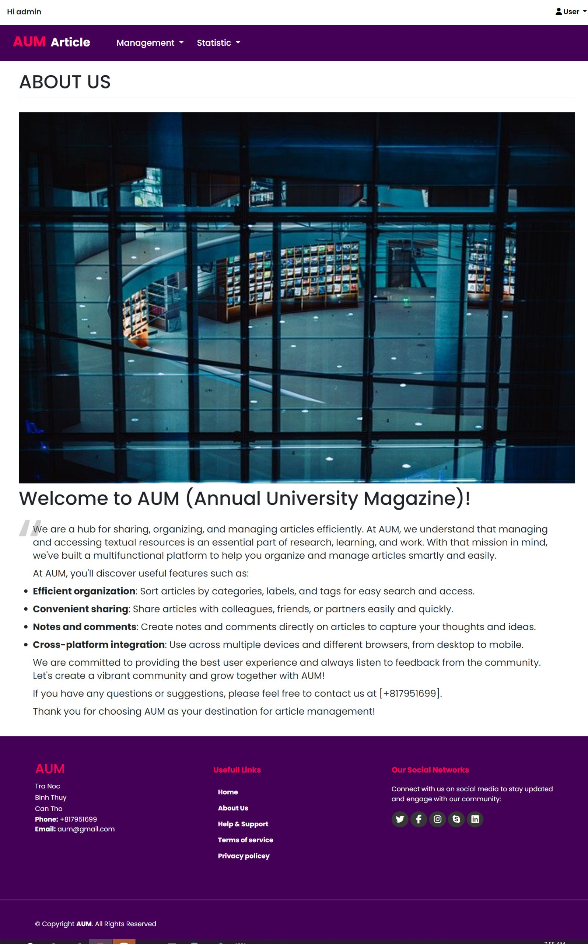

Figure 3. White and Teal colours implemented on the website

* The website is simple for users to go through and back out of. If they inadvertently access the wrong page, they may navigate their way back. This is meant to encourage user autonomy, as users frequently choose incorrectly what features to utilize on the system and will want an emergency exit that is clearly highlighted in order to leave an undesirable condition without having to engage in a protracted conversation.

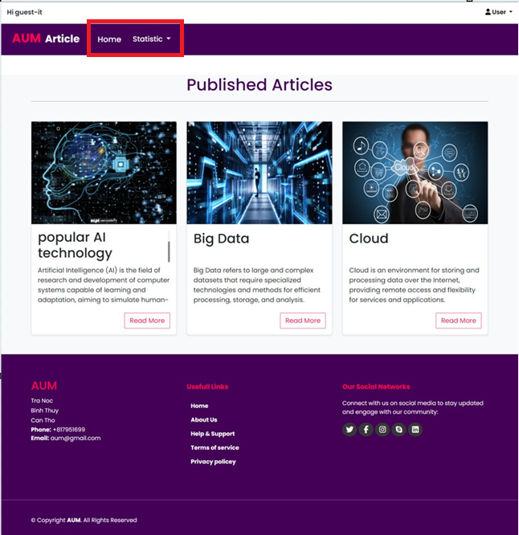

Figure 4. Website showing easy navigation

* The system's capacity to function with any type of device was another need from the client. Making the system responsive across several platforms, including phones, PCs, and tablets, satisfied this need. This has the advantage of enabling system users to access an item at any time on a variety of platforms.

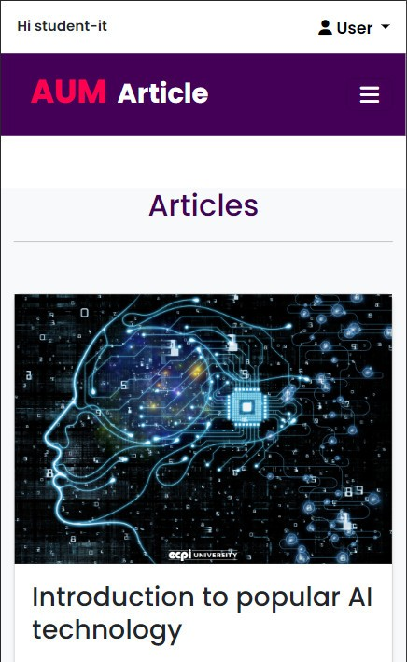

Figure 5. Responsive design on the homepage

* Security and Privacy
* The system's security features are designed to stop unauthorized users from taking any illegal or unauthorized acts on the network. Data is encrypted in the data warehouse using the Bcrypt hash security feature, which is one of the various authentications used to safeguard data kept in the system. The system is made with strict design guidelines to give consumers a system Role-based online apps often misuse their identity and privacy protection websites.

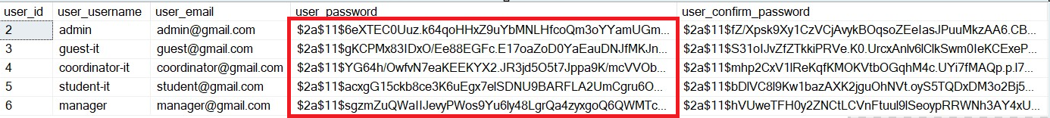

Figure 6. Bcrypt hash security feature in the database

* 1. **Nielsen’s Heuristics for User Interface Design**
* **Visibility of system Status**

According to (Nielsen, 1994), The system must always inform the user about what on going, through appropriate response within a reasonable time. We apply this to the system by promptly notify an error regarding the fields that have not been filled with valid information when the admin attempts to create an account with incomplete information and clicks the "Create" button.

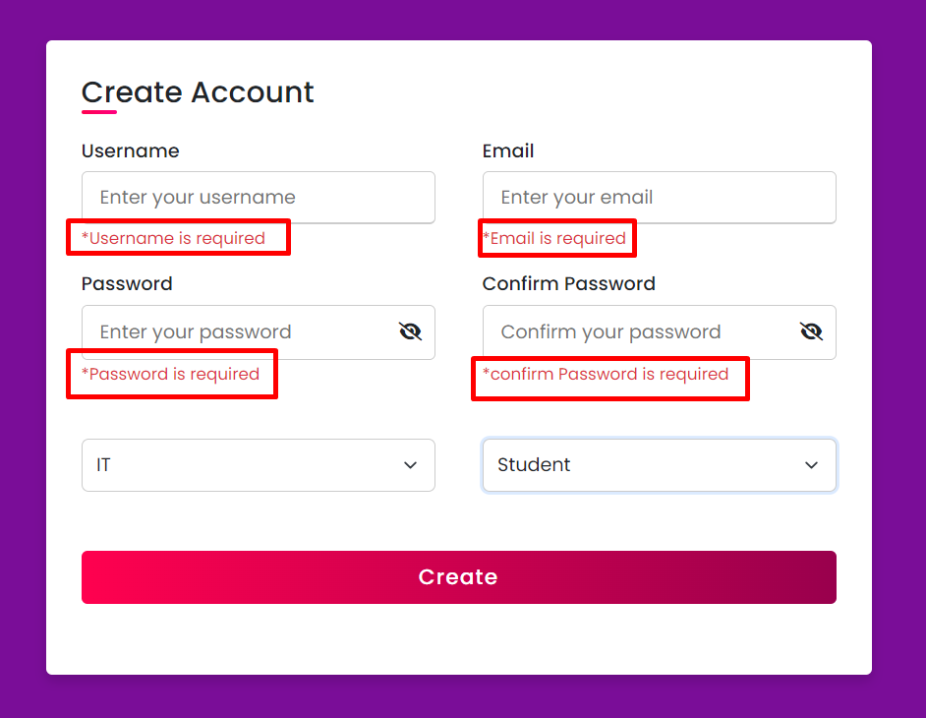

Figure 7. Visibility of system Status

* **User control and freedom**

According to (Nielsen, 1994), Users often mistakenly select system functions and will need to exit the unwanted state without having to go through a lengthy dialogue. Therefore, our system allows users to return to the previous page by clicking the "Back" button.

Figure 8. User control and freedom

* **Aesthetic and minimalist design**

According to (Nielsen, 1994), It will be simpler to maintain a system that is user-friendly when kept with a simple, clean, and minimalist user interface design. It will be feasible to finish tasks and navigate pages without overburdening the user with images and information if the screen doesn't get too cluttered. As a result, our system will adopt a minimalist approach, displaying only the data required to do the present task. Furthermore, a meticulous examination of the color scheme will ensure that the chosen hues complement one another to produce an aesthetically pleasing design.

Figure 9. Aesthetic and minimalist design

* **Help users recognize, diagnose, and recover from errors**

The error message must accurately describe the problem and provide a possible fix (no error code). To assist users in seeing and identifying these error signals, pinpoint the problem and suggest a constructive solution. These error messages should also be presented using visual treatments to help users notice and recognize them. Below is an image showing the error message when the user login with an account that does not exist.

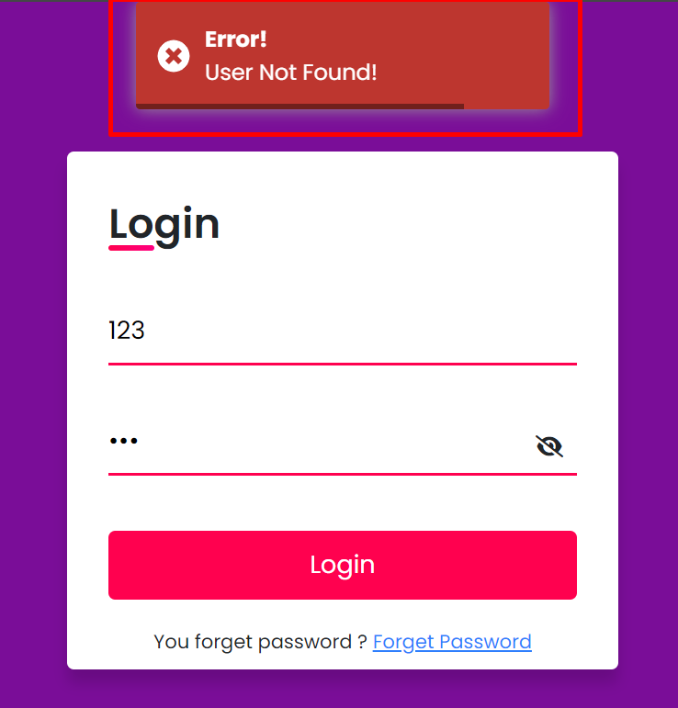

Figure 10. Help users recognize, diagnose, and recover from errors

* 1. **What else could be done**

If the product were to continue to be developed, one improvement that would be made is the system's integration with an intelligence tool like Tableau. It is possible to link statistical reports to filter data more quickly and smoothly. Tableau would assist in displaying the overall data for every faculty in an organized way using interactive graphs. Tableau is a useful tool for comparing faculty performance, which enables the institution to make strategic decisions like promoting a magazine for underperforming faculties. Tableau's device adaptability, including its ability to work with mobile phones, enables statistical reports to be adapted for a variety of devices.

All things considered, it can be said that the product was implemented in a way that satisfied the customer and allowed the designed product to effectively achieve its fullest performance potential.

1. **The Process**

The Scrum methodology was used in product implementations. The primary benefits of adopting Scrum are its time-saving nature and its iterative development process, which is fueled by ongoing input from the system's customers. Another benefit of scrum is that, as a result of meetings and cooperation, team members' production improves. Five people were selected for the team and given duties based on their areas of strength in order for the product to succeed. To make sure there was continuous communication among members of the team, they employed a variety of strategies. A method employed for carrying this out was holding weekly scrum meetings. The team meets weekly at the same place and time, and during this time, each member discusses things that need to be finished before the next meeting and those that have already been accomplished. The team also kept minutes of their weekly meetings, which included the meeting's location, time, and agenda items.

Creating a product backlog assisted the team in identifying every feature that needed to be added to the system, which was another method utilized in its development. Every participant reached a consensus over the backlog item that could be completed during the first sprint: the login feature. An assumption made by the group was subsequently added to the backlog. Along the process, more functions were added to the list throughout development. Ten percent of the scrum team's overall time was set aside for backlog maintenance, which facilitates organizing all of the requirements for weekly sprint planning.

Generally, during the development period, the team members had good communication with one another. Throughout the product's life cycle, the team was assisted by the utilization of user stories and the product backlog. By doing so, you will have fulfilled the requirements for utilizing the scrum framework and effectively use it to create a functional solution.

1. **The team** 
   1. **Team Evaluation**

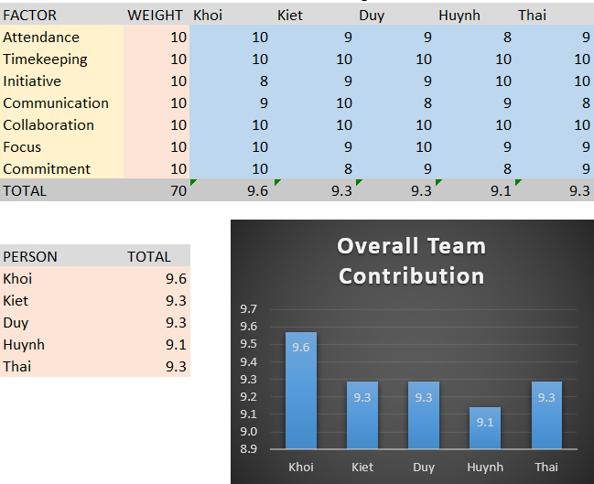

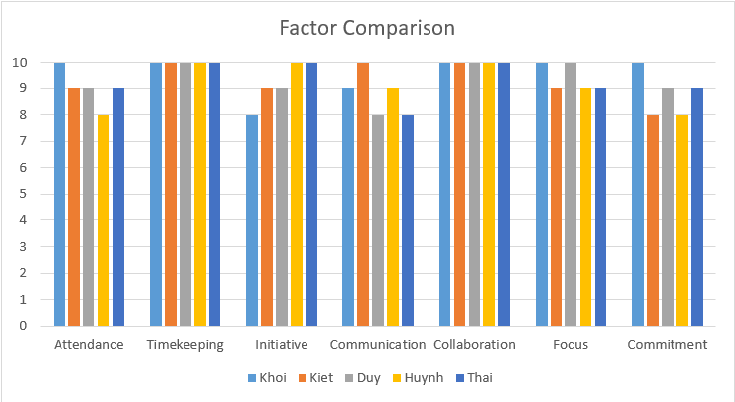

Figure 11 & 12. Team Evaluation

* 1. **Team Justification**

|  |  |  |  |
| --- | --- | --- | --- |
| **Name** | **Factor** | **Average Rating** | **Comments** |
| Khoi | Attendance: 10 Timekeeping: 10 Initiative: 8 Communication: 9 Collaboration: 10  Focus: 10  Commitment: 10 | 9.6 | Khoi is the database designer, back-end developer and leader of the team. He has guided and cooperated well with all members in developing the system to high standards. He attends weekly meetings with the team and communicates well with the team about his progress in designing the entity-relationship diagram, database collection, and system functions he is working on. he undertakes. He completes each assigned task on time. He regularly contributes to project development and works well with team members. |
| Kiet | Attendance: 9 Timekeeping: 10 Initiative: 9 Communication: 10 Collaboration: 10  Focus: 9  Commitment: 8 | 9.3 | Kiet is a back-end developer and tester. He cooperated well with all members in developing the system to high standards. He attends weekly meetings with the team and communicates well with the team about his progress in developing the system functions he is working on, and testing the system functions. He completes each assigned task on time. He regularly contributes to project development and works well with team members. |
| Duy | Attendance: 9 Timekeeping: 10 Initiative: 9 Communication: 8 Collaboration: 10  Focus: 10  Commitment: 9 | 9.3 | Duy is a back-end developer and scrum master. He cooperates well with all members in developing the system to high standards. He attends weekly meetings with the team and communicates well with the team about his progress in assigning tasks according to each team member's strengths and developing system functions that he are undertaking. He completes each assigned task on time. He regularly contributes to project development and works well with team members. |
| Huynh | Attendance: 8 Timekeeping: 10 Initiative: 10 Communication: 9 Collaboration: 10  Focus: 9  Commitment: 8 | 9.1 | Huynh is a front-end developer and design UI. He cooperates well with all members in developing the system to high standards. He attends weekly meetings with the team and communicates well with the team about his progress in building and developing the system's interface. He completes each assigned task on time. He regularly contributes to project development and works well with team members. |
| Thai (Author) | Attendance: 9 Timekeeping: 10 Initiative: 10 Communication: 8 Collaboration: 10  Focus: 9  Commitment: 9 | 9.3 | Thai is a front-end developer and design UI. He cooperates well with all members in developing the system to high standards. He attends weekly meetings with the team and communicates well with the team about his progress in designing the system's interface and building and developing the system's interface. He completes each assigned task on time. He regularly contributes to project development and works well with team members. |

1. **Self-Evaluation**

My contribution to the team's effort was immense as I was tasked with designing and developing the system's interface. I was chosen by my teammates to be a Frontend Developer and UI Designer because they believed I had the best experience in UI/UX, so I was the most suitable person to take on the role of Frontend Developer, and UI Designer. One of my responsibilities is to design and develop system interfaces. Due to my experience designing interfaces during my first two years at university, I was extremely confident in taking on this role and well-prepared for the challenges ahead.

As a Frontend Developer and UI Designer, I start by designing the system's interface as follows: First, I need to collect requirements such as the purpose of the website, intended users, and requirements. functionality, and other elements needed to build a suitable interface. Second, I need to learn and research the latest design trends to ensure the website interface reflects professionalism and modernity. Third is to determine the information organization structure on the website, including pages and links between them. Fourth, I create a preliminary design of the interface by drawing a wireframe. Here I use a tool called Draw.io to design drawings and then I choose colors, fonts, images and other design elements to create an attractive and easy-to-use interface. use. Next is to develop the interface according to the wireframes I drew using the Angular and Boostrap web application development frameworks to create a complete interface. Finally, test the interfaces on many different devices so that the system is more accessible to customers without having to worry about accessing the system with many types of devices such as laptops, tablets and smartphones.

I have successfully completed the tasks assigned by the Scrum Master, I have been fully present in team meetings and come up with many ideas to help team members choose the best ideas for development. system. When working with group members, I still encounter some difficulties such as communication because I argue about the ideas that I and the members come up with and have difficulty reaching an agreement with them. Additionally, I once failed to complete a task on time because I messed up the system's requirements and I edited it for quite a while.

1. **Conclusion**

This coursework has assessed the "Annual University Magazine" life cycle projects and reported on all pertinent product components. It should be mentioned that all of the features were implemented and the product was delivered before the deadline. This was accomplished by adhering to every agile technique component, including weekly scrum meetings, keeping track of a product backlog, and using user stories to emphasize the features of the final product. The product was reviewed in the report's first part, which also included relevant screenshots and analysis. The system's security and usability were highlighted as two of its strengths. In order to help the product assessment department rate the efficacy of the product in terms of usability and look, Nielsen's heuristics for user interface design were employed as a reference. The report's second portion assessed the system development process based on the design techniques employed and the scrum team's ability to interact with one another. This part discussed the team's successful application of scrum methods to create a functional system. Product backlogs and user stories helped in the development process and ensured that the final product was delivered to the client on schedule. This part included an evaluation of our team. An excel spreadsheet was used to grade each team member based on a variety of teamwork-related criteria. This was corroborated by remarks that explained each member's evaluation. Lastly, a personal assessment of the report was completed, including the author's input toward the group project, final output, and presentation. Overall, it can be said that a complete and effective review of every facet of the product life cycle has been conducted.

# **References**

Nielsen, J., 1994. *Usability Engineering.* s.l.:Elsevier Science.